**New Codington Festival Online Project -   
Wireframe Pilot 2**

**Project:** New Codington Festival Online Project

**System:**  FERS – Release 1

Table of Contents

1 Wireframe 2

# Wireframe

**Login**

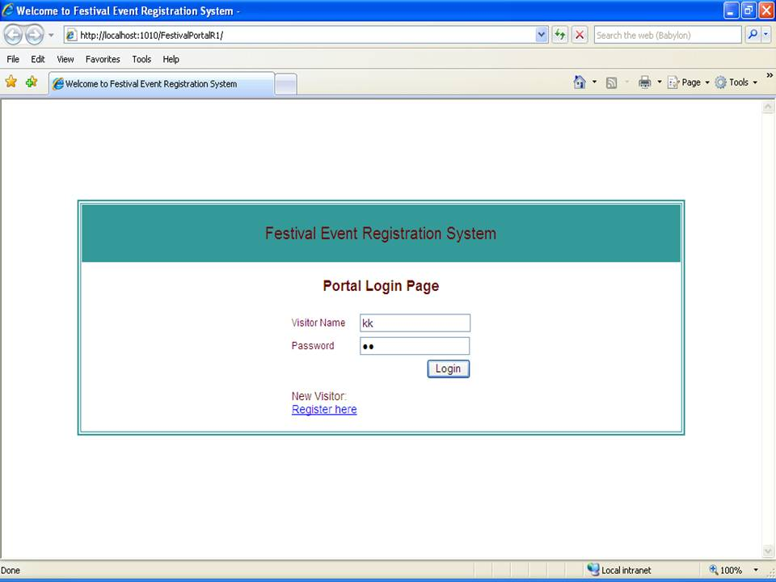

**Festival Portal**

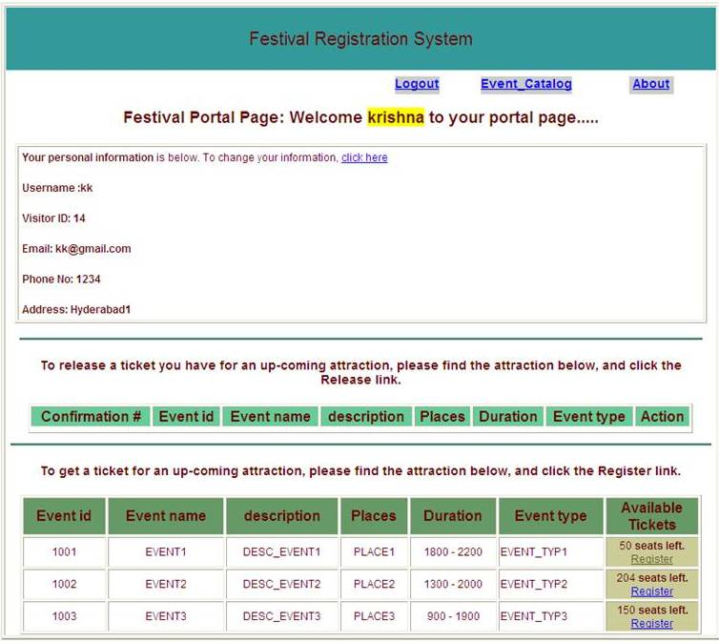

**Update Visitor’s Information Page**

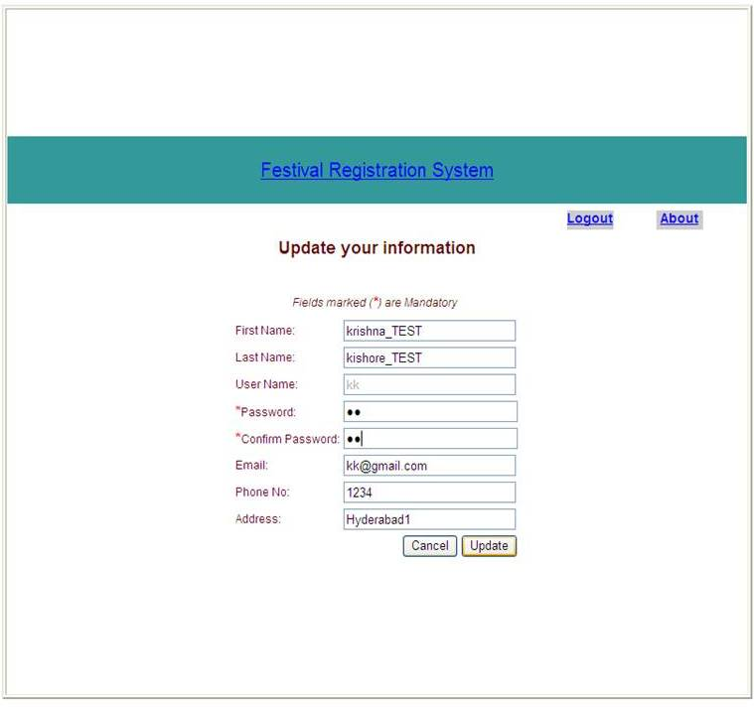

**Updated Visitor information – Confirmation Page**

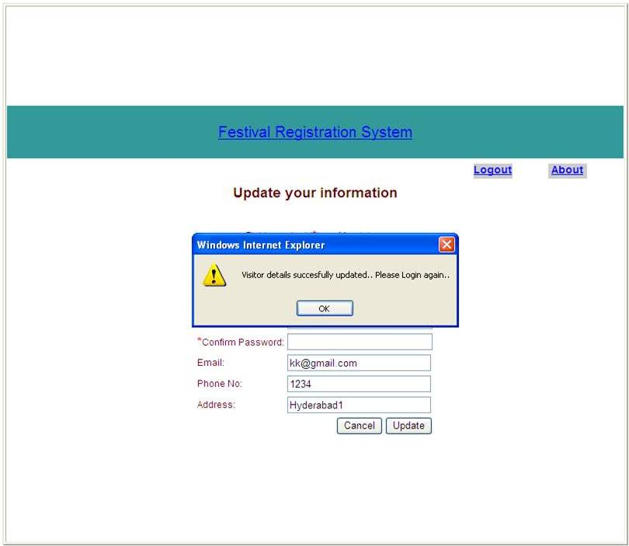

**Portal Page updated after successful Registration for an event**

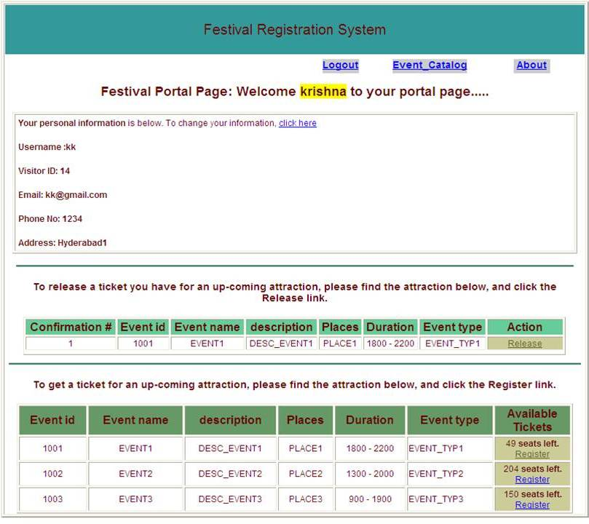

**Updated Portal Page after unregistering from an Event**

